
BAKERSFIELD COLLEGE

Electronics

Raspberry Pi Pico

Project 02: LED Flashing Onboard

1. Introduction:
For Raspberry Pi Pico beginners, we will start with some simple things. In this project, you only need a Raspberry Pi Pico and a USB cable to complete the " LED Flashing Onboard " project, which is a test of communication between Raspberry Pi Pico and the PC as well as a primary project.

2. Wiring Up:
In this project, we use a USB cable to connect the Raspberry Pi Pico to the computer.
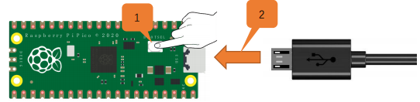

Raspberry Pi Pico USB Cable

3. Test Code:
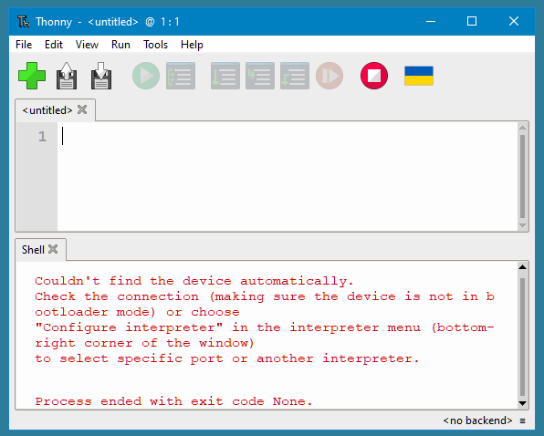
Connect the pico board to the PC, then open, Thonny is a free, easy and open-source integrated development environment (IDE) with Python built-in that is designed for us beginners to learn programming.

It supports compiling or debug programs.

In the "Shell" window, you can view the error information and output results generated during the running of your program, and you can query step-by-step expression evaluation, detailed visualization of the call stack and a mode for explaining the concepts of references and heap to help improve the compile program.

The Thonny (IDE) will be used for all the Raspberry Pi Pico – Projects.


When you first open ‘Thonny IDE’ it will look like this: (Because the Pi is not Plugged-in.)

After the Pi is Plugged-in click the: “Stop /Restart backend”

The ‘Thonny IDE’ will look like this: (Because the Pi is Plugged-in)
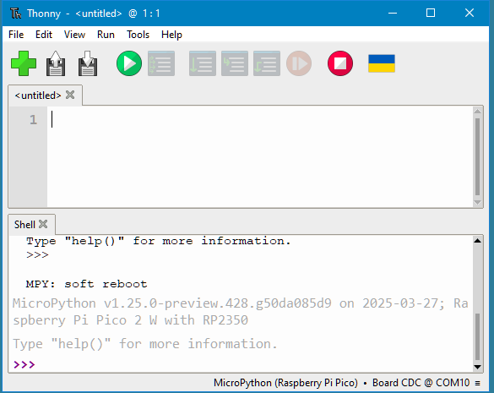

The ‘Thonny IDE’ it will display the Pi and the IDE with Python. ↑
At this point a program could be type-in or it can be loaded from a file.

Go ‘File’ then ‘Open’ or click “Open...” (or skip down to 4. The IDE and type in by hand)

Click ‘This computer’.

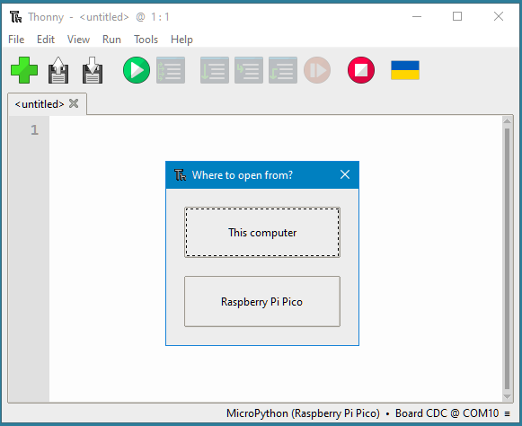

and choose the file to load. (#01 – LED Flashing Onboard #1)
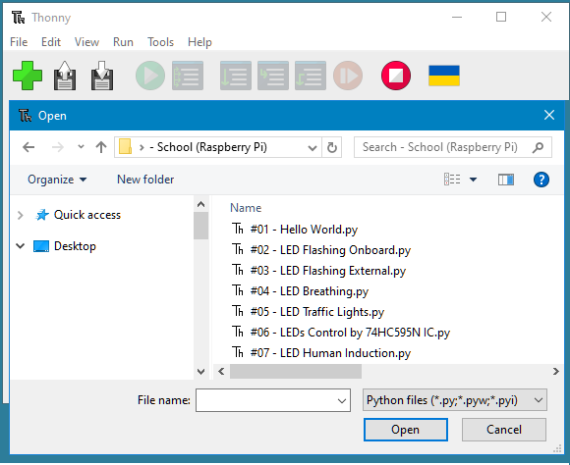

4. The IDE:
The IDE will look like this:
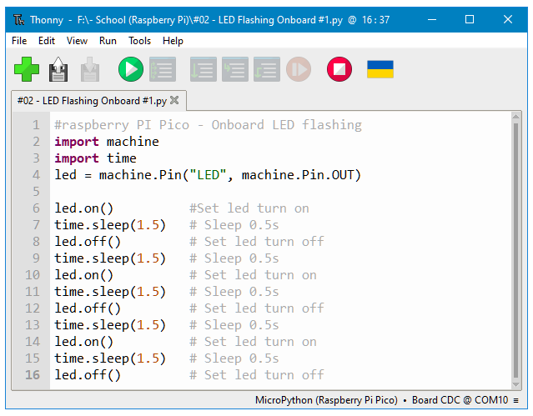


Now click the ‘Run’ then ‘Run current script’ or click the:
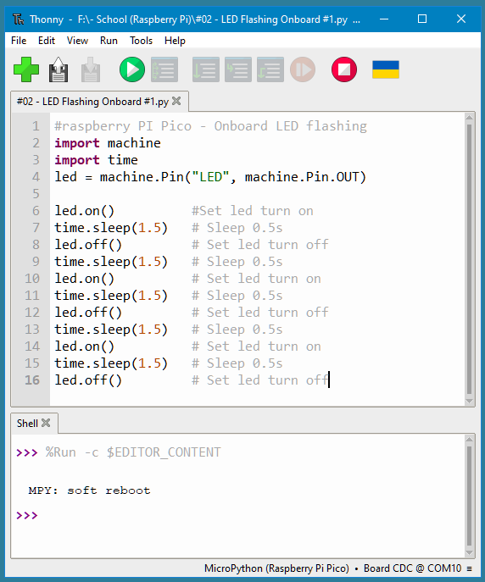

The bottom half (Shell X) of ‘Thonny’ will not have a display output, but the onboard LED on the Raspberry Pi Pico will blink on and off 4 times.
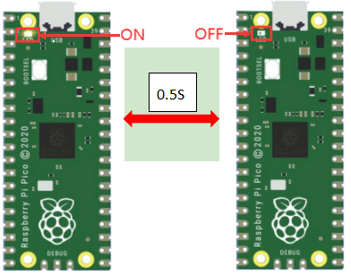
Note: The code here runs offline.


If you want to Stop running offline and display the information in the “Shell” window, simply click in Thonny software.

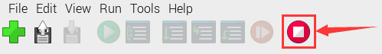

There are three (3) different code versions of the: LED Flashing Onboard.

You may want to add your own touches and modifications to come-up with other versions and timing intervals…

